Student Attendance MANAGEMENT SYSTEM

**Abstract:**

Student attendance management system mainly focuses on keeping track of student attendance. This website is created by using PHP and Bootstrap. To store the data and retrieve the data we need database MySQL. It contains two panels Student, Counsellor and an Admin.

A counsellor/teacher can only view their students attendance but cannot make any changes.

A student can view their attendance but cannot make any changes in attendance except their profile.

An administrator has full control over the system. He/she can manage attendance of students. Here, an admin has the right to the management of the students and professors. To be more precise, the administrator plays an important role in maintaining the whole system. Administrator manually checks the student’s attendance and they can edit the attendance of the students if needed. After completion of checking the attendance, admin will publish the attendance. Then counsellors can be able to view the attendance of their respective students by logging in.

**Outputs:**

**Home Page:**

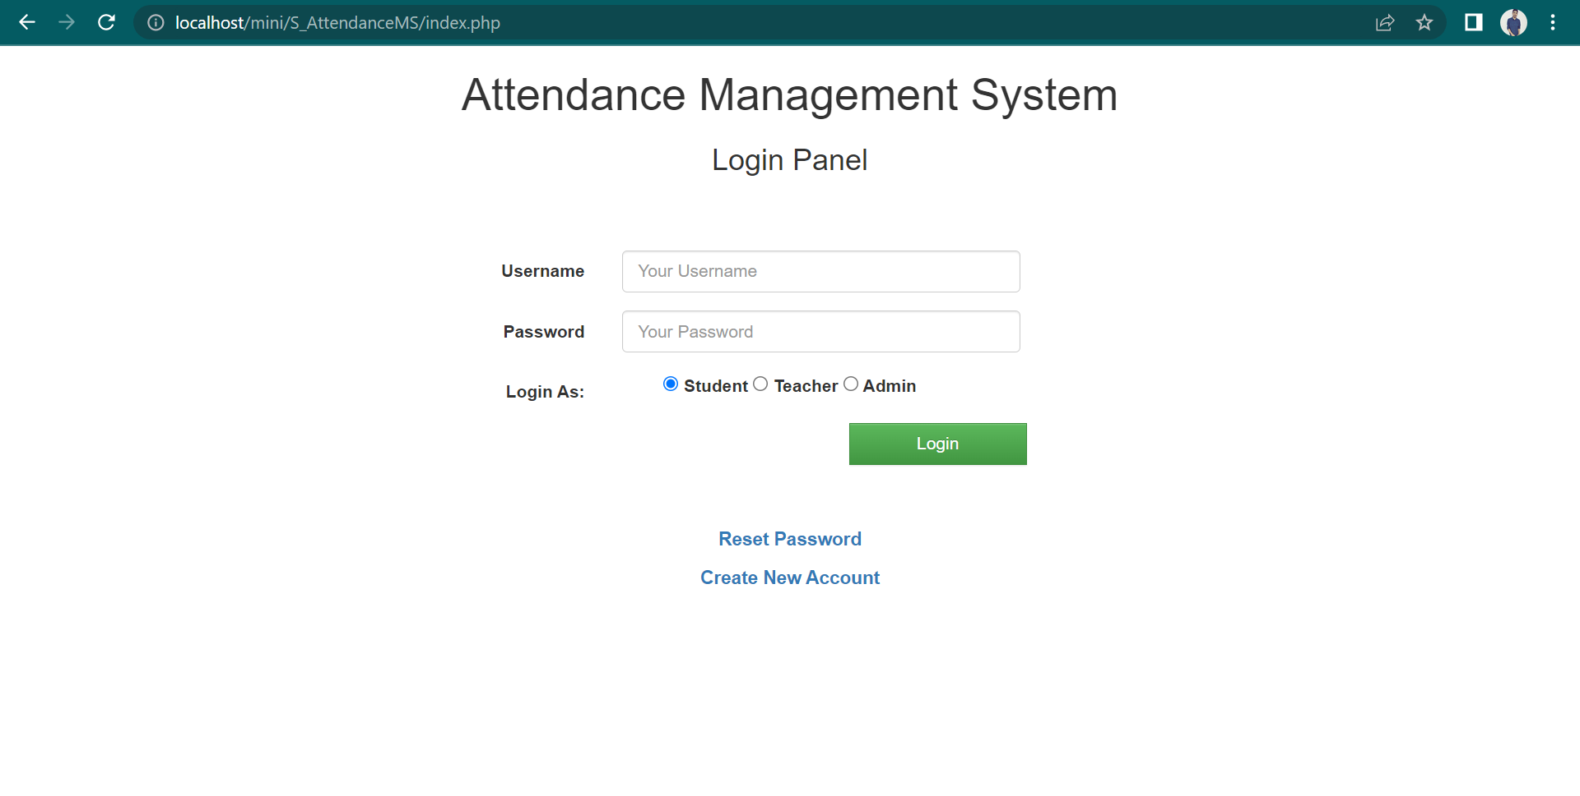

**Teacher Login:**

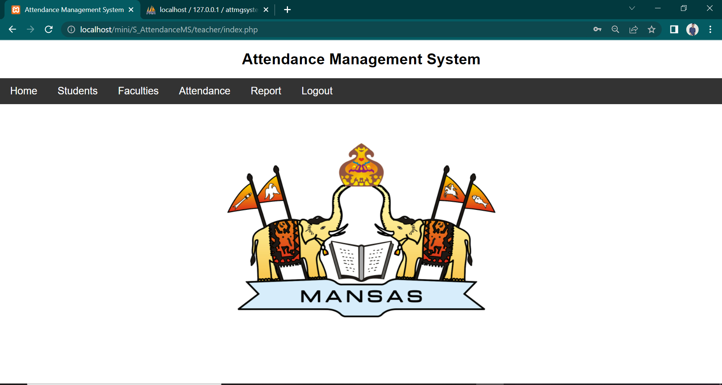

Attendance module:

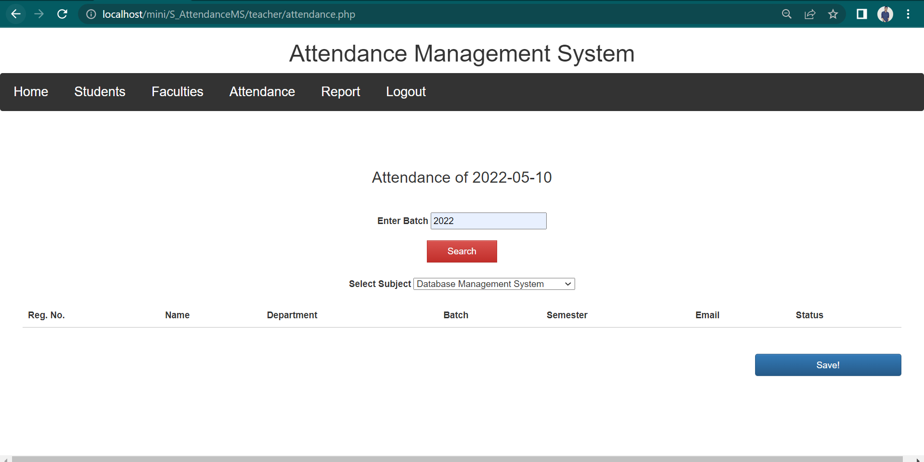

**Student login:**

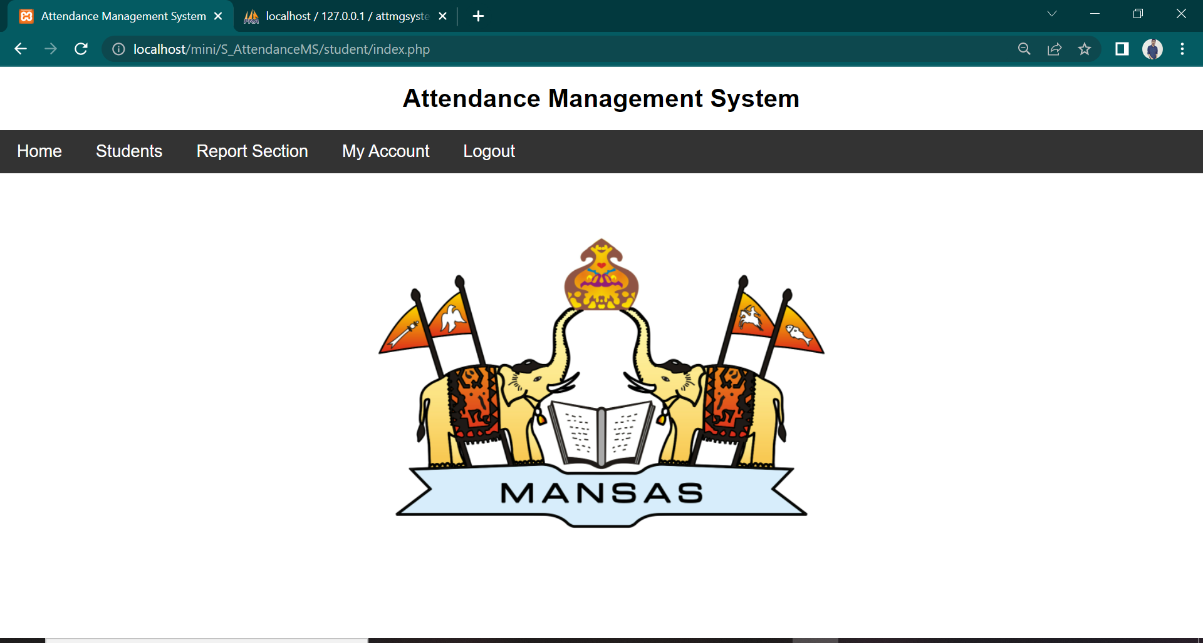

**Admin login:**

Create Users module:

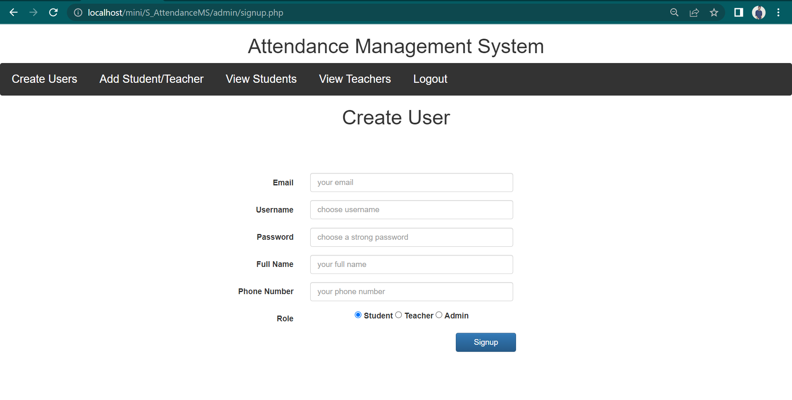

Add Student/Teacher module:

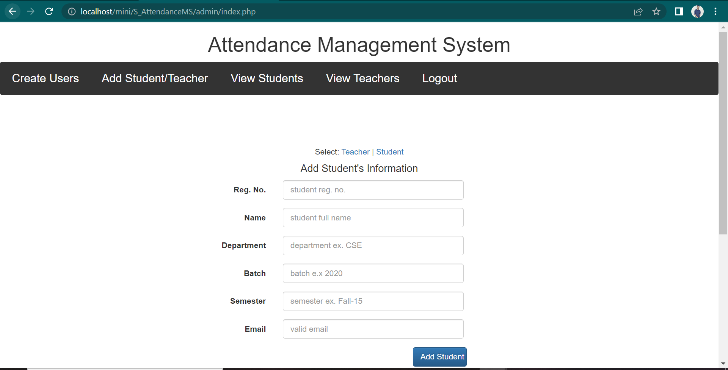

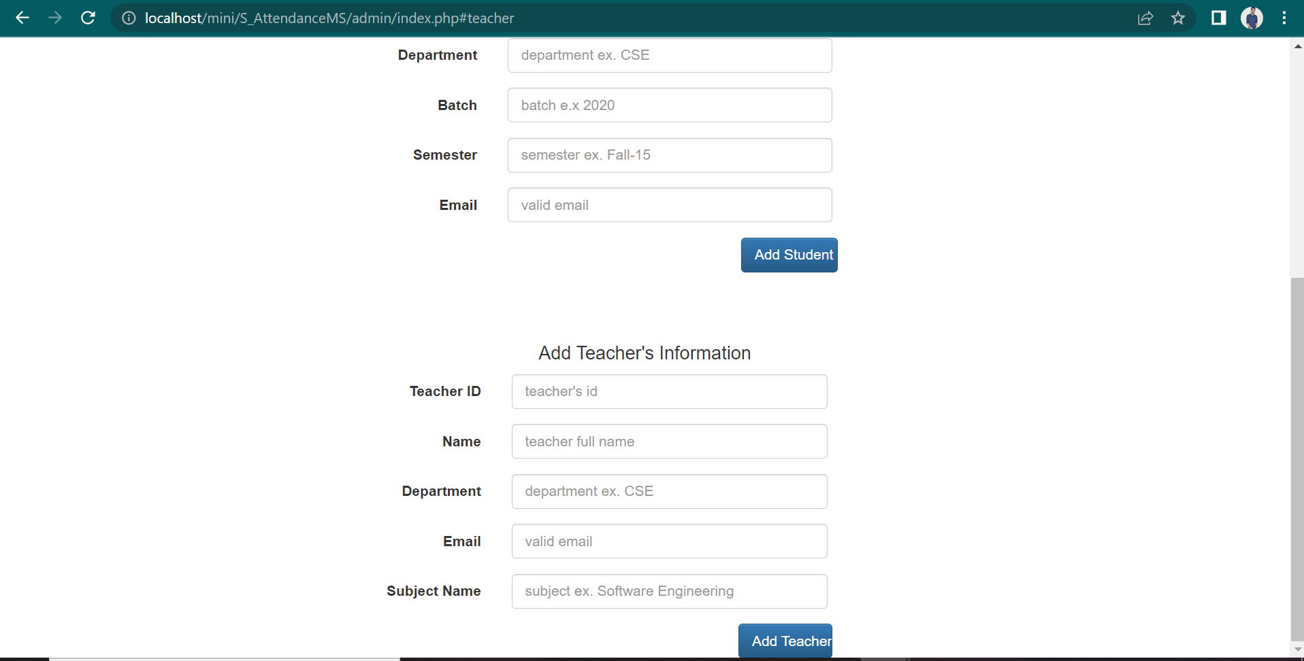

View Students module:

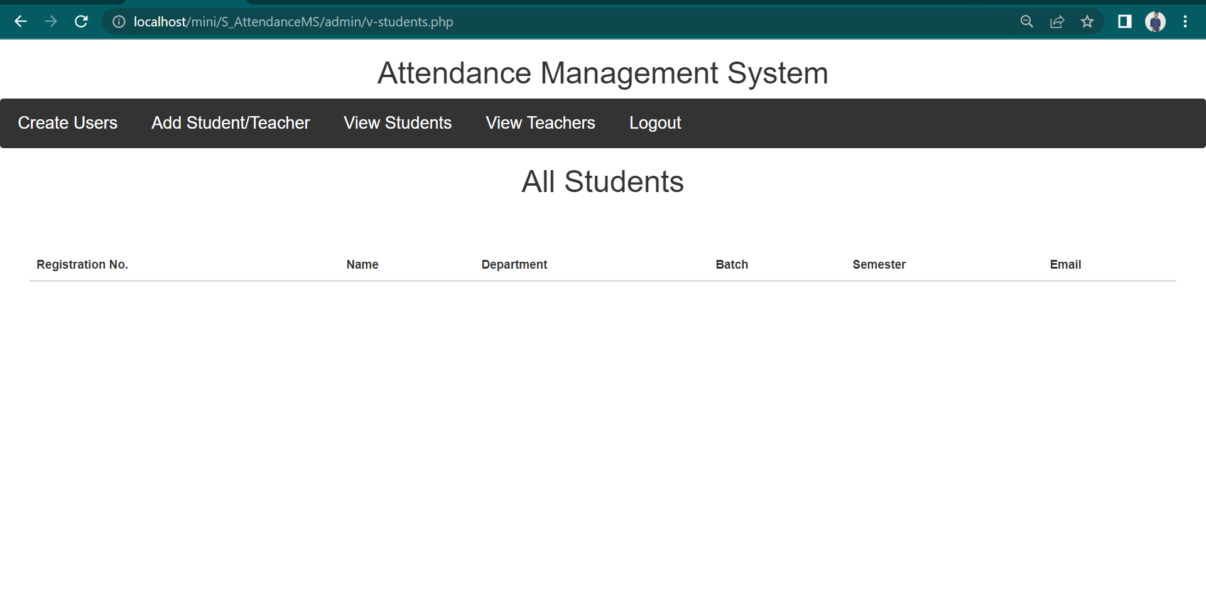

View Teachers module:

